Для любого **auth**-user реализуйте **RESTful-create** для **messages**:

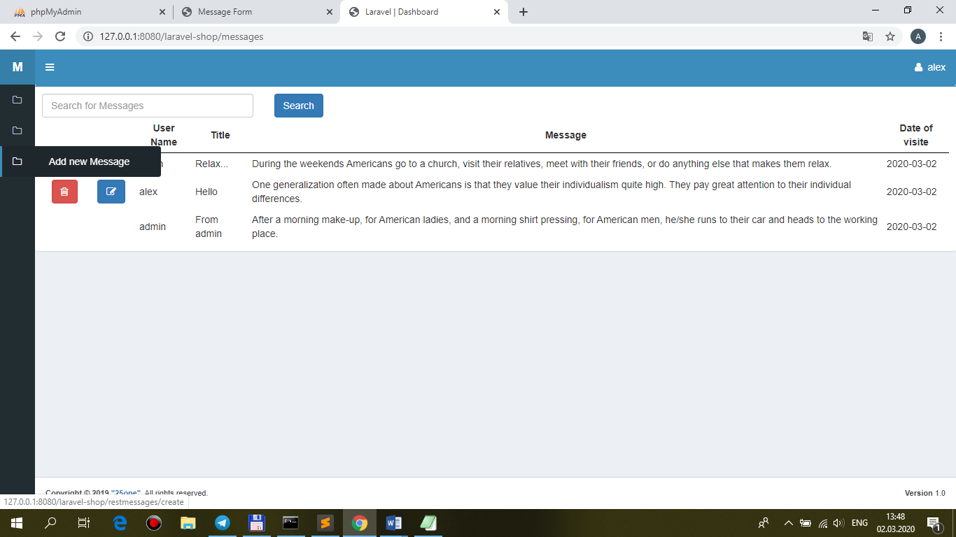

**views\front\messages\layout.blade.php**

…

<li>

<a href="{{ url('/messages') }}">

<i class="fa fa-folder-o"></i> <span>List of Messages</span>

</a>

</li>

**@auth**

**<li>**

**<a href="{{ route('restmessages.create') }}">**

**<i class="fa fa-folder-o"></i> <span>Add new Message</span>**

**</a>**

**</li>**

**@endauth**

</ul>

</section>

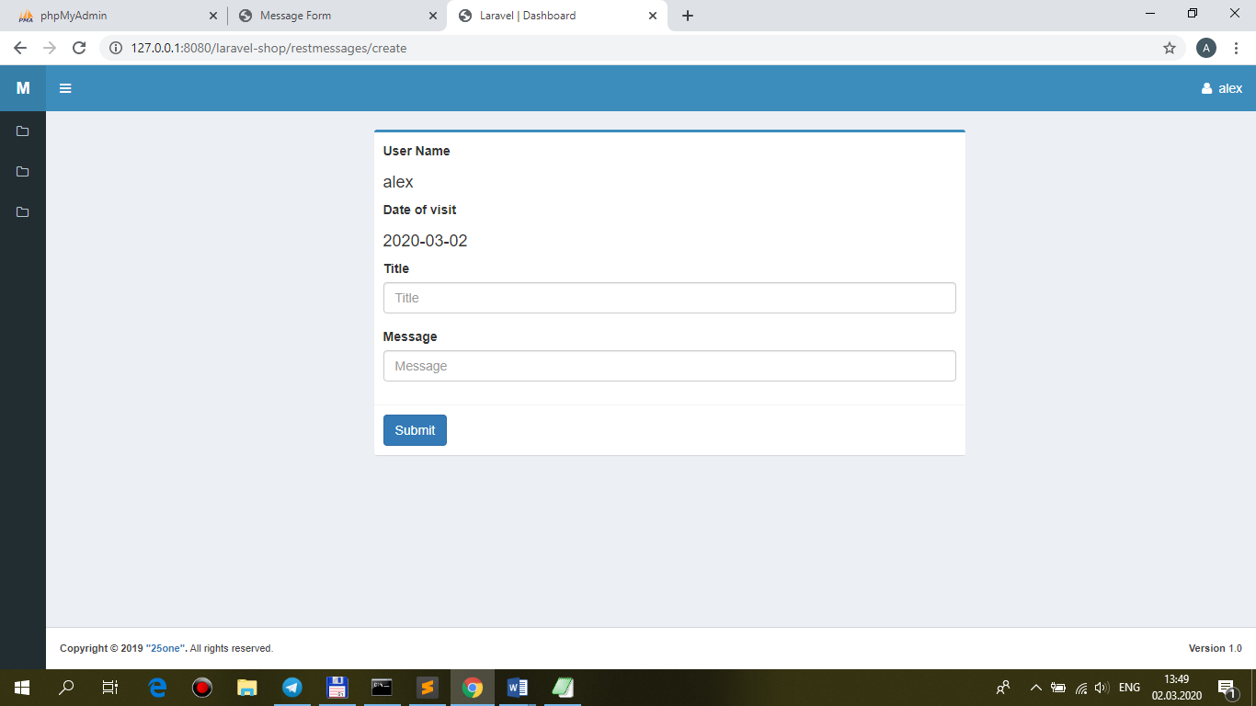

**MessageController.php**

/**

* Show the form for creating a new message.

*

* @return \Illuminate\Http\Response

*/

public function **create()**

**{**

**return view('front.messages.restmessages.create');**

}

**views\front\messages\restmessages\create.blade.php**

@extends('front.**messages.restmessages.**template')

@section('form-open')

<form method="post" action="{{ route(**'restmessages.store'**) }}">

{{ csrf_field() }}

{{ method_field('POST') }}

@endsection

**views\front\messages\restmessages\template.blade.php**

…

@yield('form-open')

<div class="box-body">

<div class="">

<label for="name">@lang('User Name')</label>

**<h4>@if(isset($message)){{$message->user->name}}@else{{auth()->user()->name}}@endif</h4>**

</div>

<div class="">

<label for="name">@lang('Date of visit')</label>

**<h4>@if(isset($message)){{$message->datevisit}}@else{{date('Y-m-d')}}@endif</h4>**

</div>

2.Для любого **aut**h-user реализуйте **RESTful-store** для **messages**:

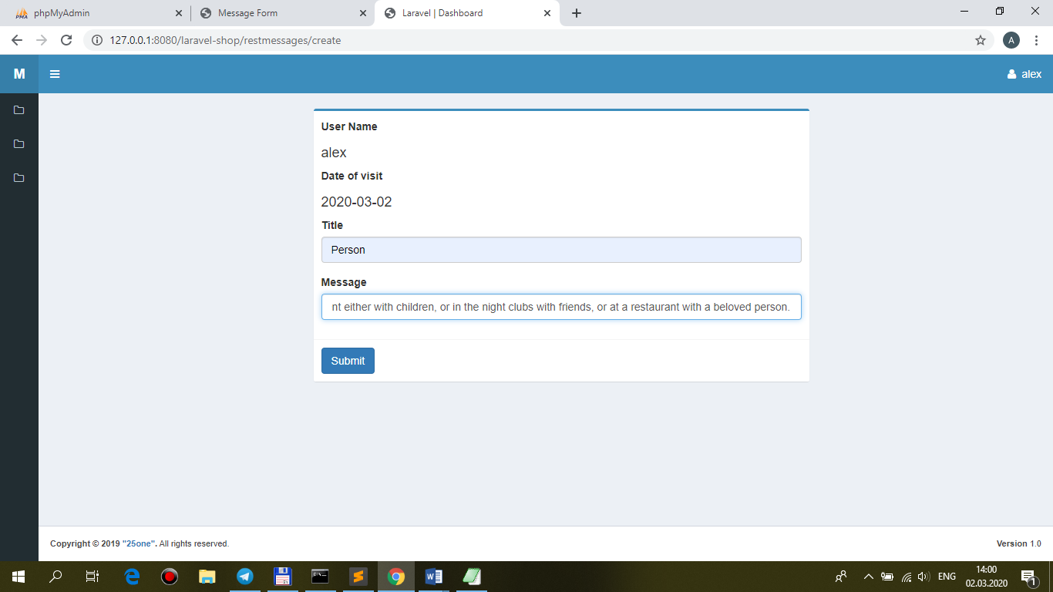

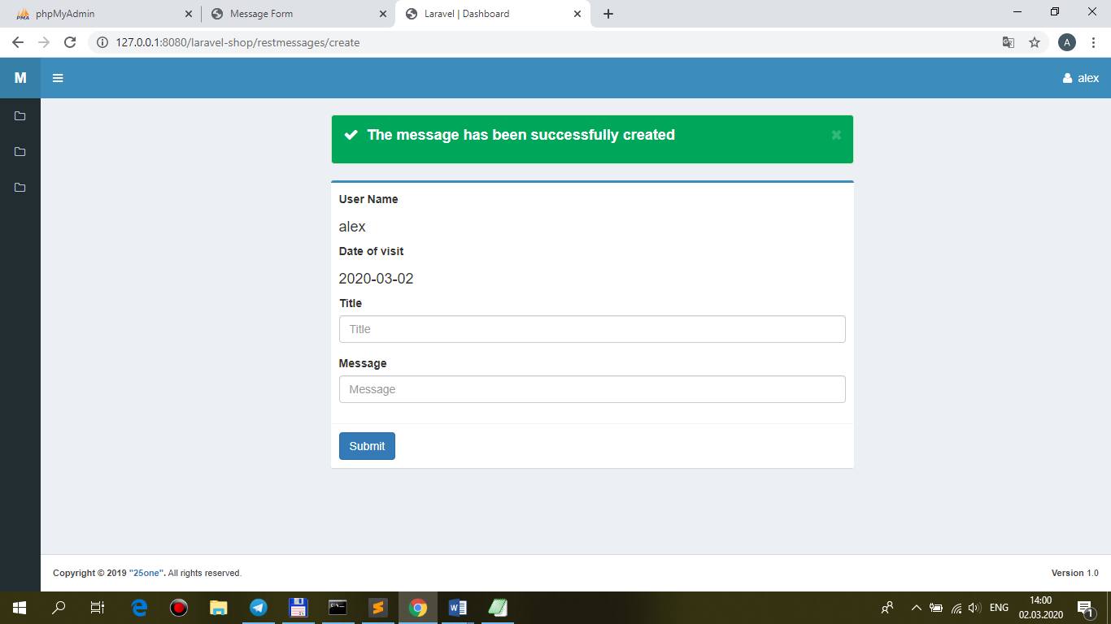

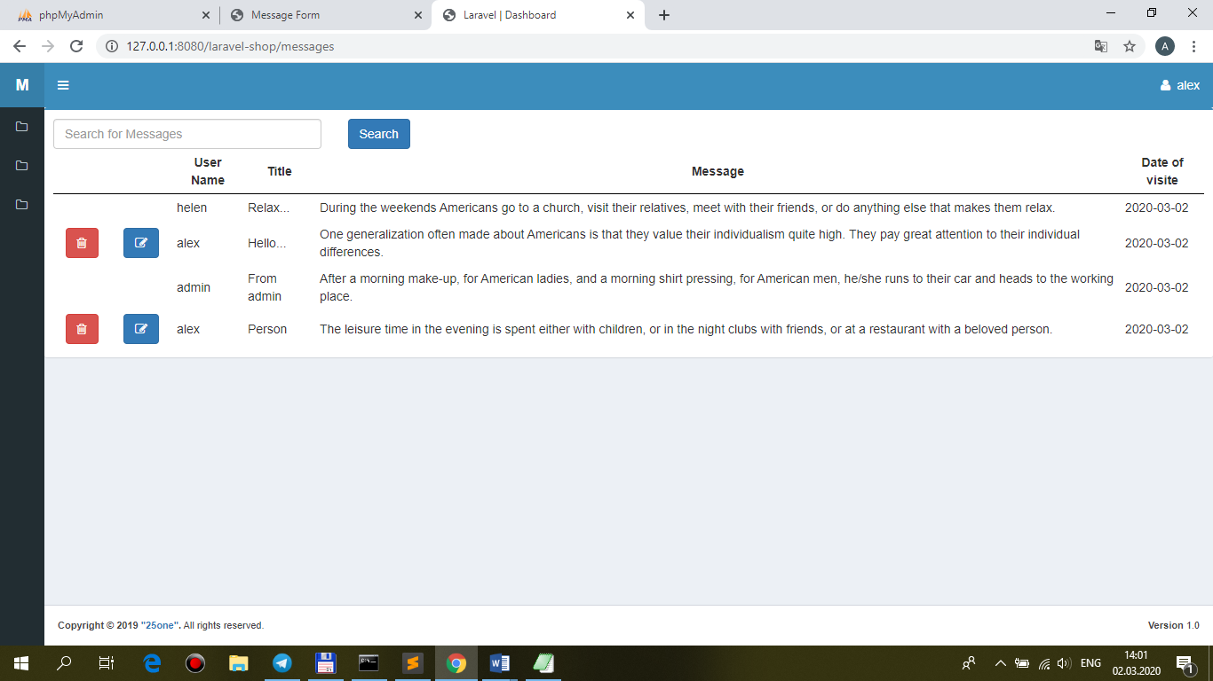

**MessageController.php**

/**

* Store a newly created message in storage.

*

* @param \App\Http\Requests\MessageRequest $request

* @return \Illuminate\Http\Response

*/

public function **store(MessageRequest $request)**

//public function store(Request $request)

{

**$this->repository->store($request);**

**return redirect(route('restmessages.create'))->with('message-ok',** __('The message has been successfully created'));

}

**MessageRepository.php**

/**

* Store message.

*

* @param \App\Http\Requests\MessageRequest $request

* @return void

*/

public function **store($request)**

**{**

**Apimessage::create($request->all());**

}